Privacy  Copyright © 2012 ECSI. All rights reserved. | 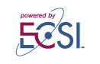

The People for Community Improvement

Feed LA Food Pass Out
“Food is our most basic Need”
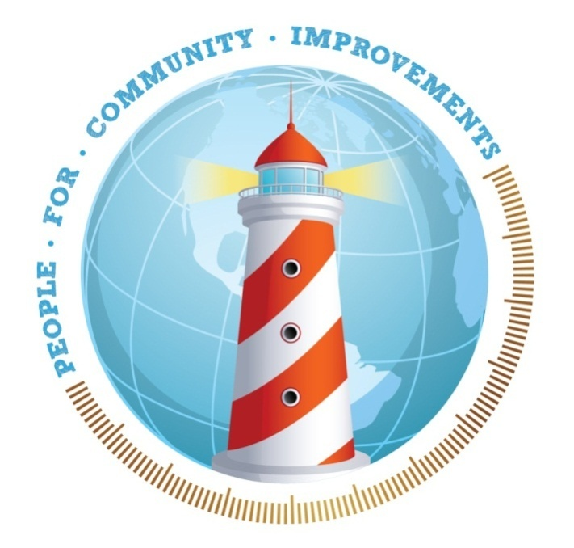

Every 2nd & 4th Friday of the Month
Time: 11am – 2pm
Location: 13008 S. Figueroa St
Los Angeles, CA 90061
For More Info Call:
(323) 303-3339
Web: www.pcicenter.org
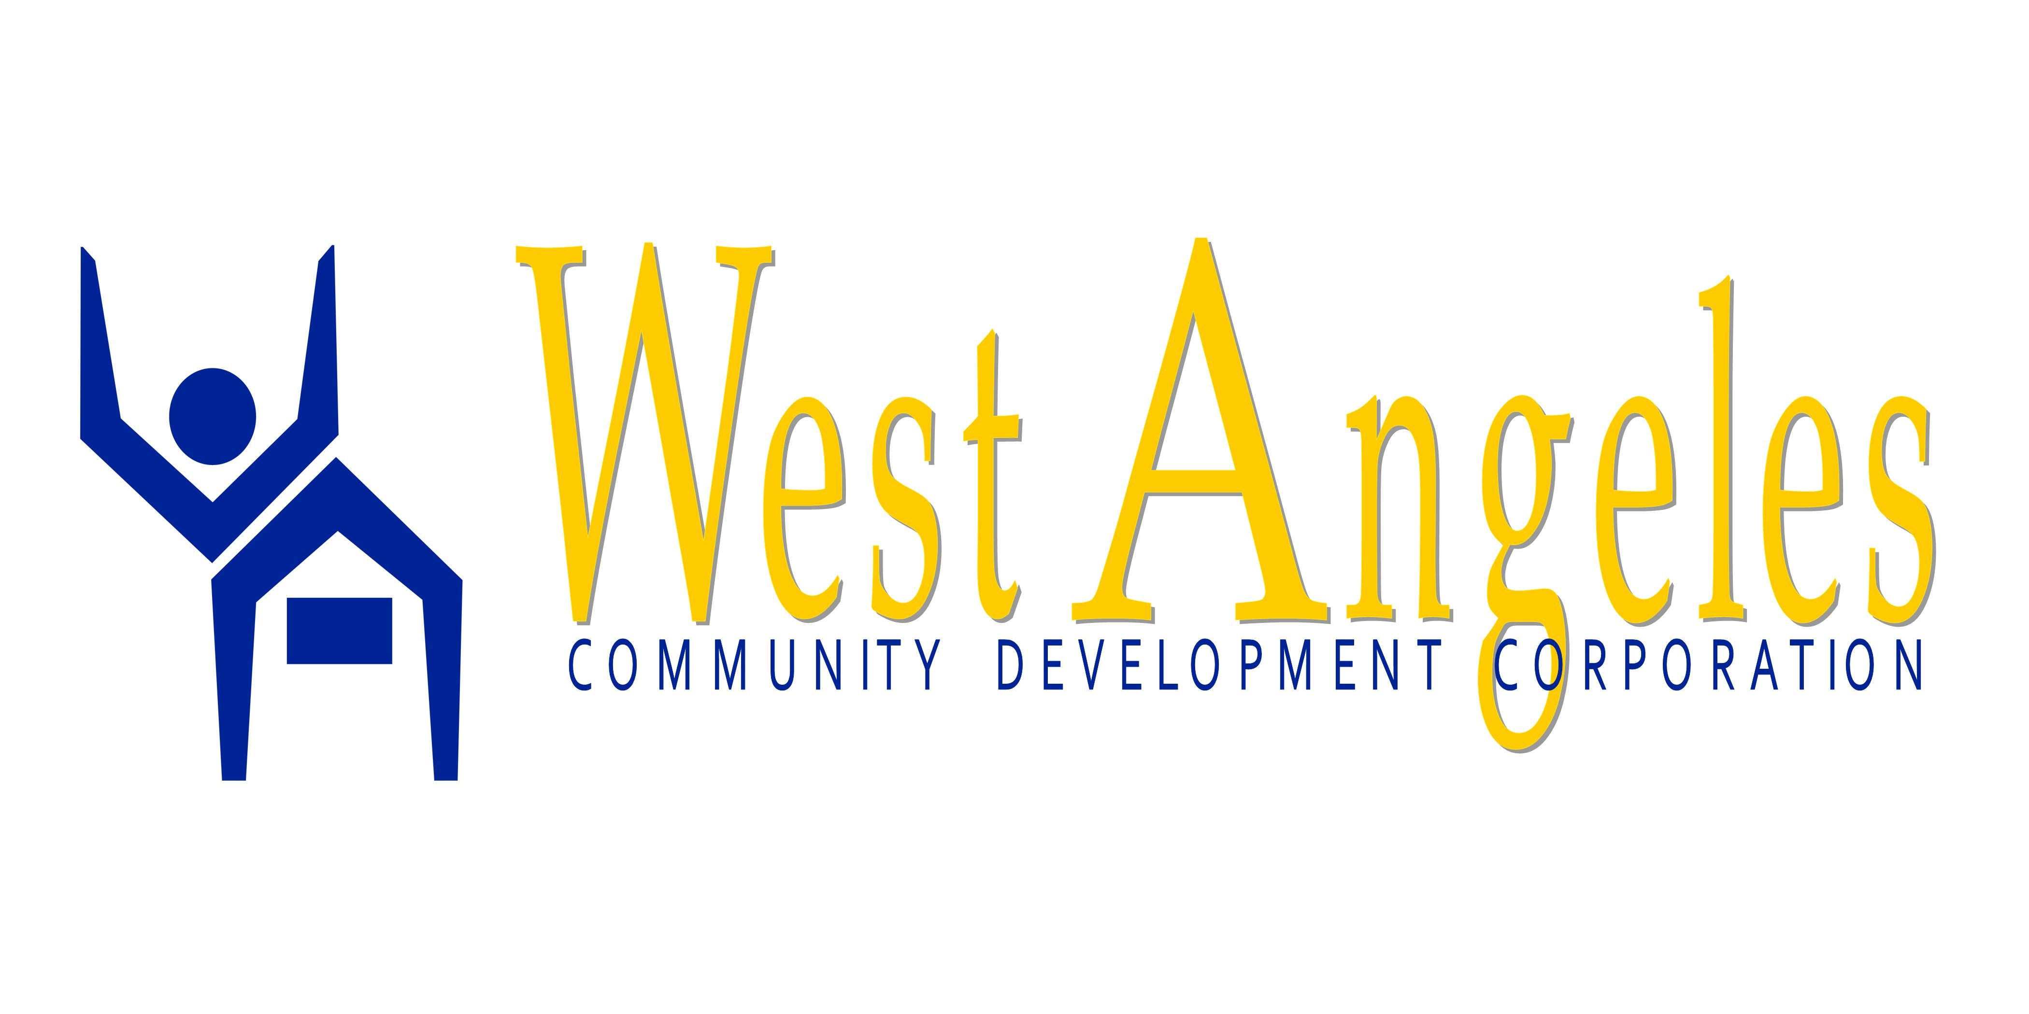 ID Required 