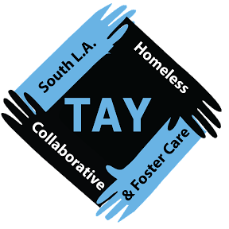

USC Bike Give Away

The University of Southern California Public Safety and the South Los Angeles Homeless TAY & Foster Care Collaborative have partnered to give back to their surrounding community in the South Los Angeles region. Highly renowned academic and public service partners would like to offer 15- 20 free bikes to homeless youth who are faced with the daily challenges of transportation. The free bikes have been held on reserve specifically for homeless or formerly homeless transition age youth (age 16-25 years old) who would like to take advantage of this giveaway opportunity. Further criteria for youth to pick up a free bike is stated below. Please fill out this form and email it to Summer Reed at sreed@southlatay.org for consideration. This is due April 6, 2015. Due to the nature of this event, resources are limited and bikes are first come, first serve. Good luck!

USC Public Safety Bike Give Away Criteria (Please Print!)

Section 1:

First Name: | Last Name:
Date of Birth: | Age:
Race/Ethnicity: | Address (if any):
Email: | Phone Number:

Section 2:

Organization/Agency Provider: | Organization/Agency Provider Contact:
Organization/Agency Provider Phone Number: | Are you homeless or have been formerly homeless?  Y / N
Have you ever been in foster care? Y / N | Are you in any educational program right now?  Y / N  If so, where?  ______________________________________  ______________________________________
Are you going to school -  Full time  Part time/Half time  Just Enrolled  Returned  (please circle one) | Are you working a paid or unpaid job/internship right now? Y / N
Job/Internship: | Supervisor Contact Information  (Name & Phone Number):  _______________________________________  _______________________________________
Are you receiving housing support of any kind?  Y / N | Please describe your housing situation to the best of your ability:  ___________________________________________________________________________________________________________________________

If you have any questions or concerns about the USC Bike Give Away, please contact Summer Reed at sreed@southlatay.org

Thank you so much!

